**Development of Multimodal Quantitative MRI Techniques to Assess Brain Tissue Microstructure in Multiple Sclerosis**

*Mathieu Boudreau*

*Supervisor: Bruce Pike*

PhD Progress Meeting

Biomedical Engineering Department

McGill University

**FINAL - 11/18/13 10:42 PM**

**1. Introduction and Objectives**

Multiple sclerosis (MS) is arguably the most disabling chronic neurological disease affecting a sizable portion of young adult Canadians. While the trigger of the disease is still unknown, considerable efforts have been made in the last few decades at investigating the progression of the pathology of MS. Magnetic resonance imaging (MRI) has emerged as an important imaging modality for diagnosing MS by detecting MS lesions and, in some instances, measuring multiple aspects of the disease. Some techniques provide mostly qualitative features such as T2 weighted images, but more recently quantitative measures of myelin and water content have been achieved with novel MRI techniques such as quantitative magnetization transfer (qMT) imaging and quantitative T2. Until now, most of the effort at characterizing MS with MRI has concentrated on white matter (WM) pathology, but recent post-mortem studies have emphasized the importance of cortical grey matter (GM) pathology to fully characterizing the disease. **In this thesis, we aim to develop a fast high-resolution whole-brain quantitative magnetization transfer method capable of characterizing white and gray matter MS pathology and to investigate the spatial relationship between pathology in both tissues.**

**2. Abbreviated Literature Review**

**2.1 Multiple Sclerosis**

Canada has one of the highest occurrences of MS in the world. MS occurs mostly in women, with clinical onset typically beginning between ages 15-40 ([1](#_ENREF_1)) and burdens the patient for their entire lifetime. MRI plays a crucial role in the diagnosis of MS, as described by the McDonald Criteria (last revised in 2010) ([2](#_ENREF_2)). The most common type of MS is conventionally characterized as intermittent attacks of focal WM inflammation and demyelination (plaques), separated by periods of relative stability ([3-5](#_ENREF_3)). Demyelination in MS WM is believed to be a result of an immunologically mediated attack on myelin and oligodendrocytes([4](#_ENREF_4)). Although MS has mostly been described as a WM disease, post-mortem histological evidence has shown many abnormalities in cortical GM of MS patients ([6](#_ENREF_6),[7](#_ENREF_7)). GM lesions are characterized by demyelintation, axonal and dendritic transection, neuronal apoptosis and limited inflammatory cell content compared to WM lesions ([8-12](#_ENREF_8)). One post-mortem study observed that 26% of MS lesions involved some GM ([13](#_ENREF_13)). Another recent study reported that cortical GM pathology significantly correlated with neurological impairment in relapse-remitting MS patients ([14](#_ENREF_14)). Despite this, most MRI techniques currently in use concentrate on WM lesions. The development of MRI methods capable of quantifying cortical GM pathology is important to fully characterize MS.

**2.2 Magnetic Resonance Imaging of MS**

MRI is well known to be very sensitive to various pathologies related to MS ([2](#_ENREF_2),[7](#_ENREF_7),[15-21](#_ENREF_15)). The conventional MRI characteristic of MS is hyperintense signals in T2-weighted MRI of multiple focal WM lesions. However, T2 hyperintensity has little specificity to the lesion environment, as multiple pathological changes such as acute inflammation and axonal loss can lengthen T2. Conventional MRI also does not detect the full extent of MS pathology in regions referred to as normal appearing white matter (NAWM) and cortical GM. Brain atrophy, a common disease progression indicator for many neurological diseases such as MS, can also be quantified using MRI ([14](#_ENREF_14),[22-25](#_ENREF_22)).

Cortical GM lesions typically elude MRI detection with clinical MRI scans ([26](#_ENREF_26),[27](#_ENREF_27)). New techniques such as double inversion recovery (DIR) have shown better detection of cortical lesions. DIR uses two inversion pulses that null both WM and CSF, ideally leaving mostly GM signal ([28](#_ENREF_28)). However, low SNR and CNR of DIR limit the detection of subtle cortical lesions, such as Type 3 subpial lesions.

**2.3 Quantitative MRI**

Quantitative MRI techniques, such as quantitative T1, T2, diffusion, and magnetization transfer, have become the focus of research development for MS due to their promise of providing hardware and site independent MRI measures and better MS diagnostic specificity ([29](#_ENREF_29)). MT measures have been shown to strongly correlate with myelin content in brain white matter ([16](#_ENREF_16),[17](#_ENREF_17)), and it is expected that a similar correlation with grey matter can be observed if resolution and SNR is improved ([20](#_ENREF_20)). Diffusion MRI can be used to trace the fiber connections in the brain with tractography. Multiple axon orientations within an image voxel are difficult to resolve with diffusion tensor imaging, but recent advancements such as high angular resolution diffusion imaging (HARDI) and diffusion spectrum imaging (DSI) provide improved fiber tracking in areas of fiber crossing and branching ([30-33](#_ENREF_30)). Changes in diffusion MRI metrics such as radial diffusivity can also characterize MS lesion ([34-36](#_ENREF_34)).

**2.4 Magnetization Transfer**

Magnetization transfer (MT) is the MR phenomenon of nuclear spins in different environments exchanging magnetization through coupled relaxation ([37-40](#_ENREF_37)). This method provides an indirect measurement of hydrogen in a semi-solid macromolecular state, as signal from these molecules is undetected with conventional MRI due to the characteristic fast signal decay of solids. This technique provides an indirect measurement of relative semi-solid (e.g. myelin) density. Although MT has been mostly used to investigate multiple sclerosis, other applications include HIV ([41-43](#_ENREF_41)), Alzheimer’s disease ([44-47](#_ENREF_44)), and articular cartilage ([48](#_ENREF_48),[49](#_ENREF_49)).

The most simple and common magnetization transfer metric is the magnetization transfer ratio (MTR), which consists of two measurements: one with and one without an off-resonance saturation pulse. Although MTR has been shown to correlate with T1/T2 weighted MRI images and histology ([16](#_ENREF_16)), quantitative methods using mathematical models of the magnetization transfer ([38](#_ENREF_38),[50-54](#_ENREF_50)) can provide a more quantitative analysis of the disease. Schmierer et al. ([17](#_ENREF_17)) compared qMT measurements with quantitative histology on post-mortem MS brains and observed that myelin density was strongly correlated with the restricted pool size ratio (F), and that F could distinguish between normal appearing WM and remyelinated WM lesions; however, cortical pathology was not examined. qMT MRI protocols have historically suffered from very long acquisition times due to the large number of measurements typically required. Several developments have been introduced to overcome this limitation, such as optimal sampling schemes ([55](#_ENREF_55),[56](#_ENREF_56)), reduced sampling by parameter restricting ([57](#_ENREF_57),[58](#_ENREF_58)) and novel qMT re-interpretations of rapid pulse sequences ([59](#_ENREF_59)).

**2.5 Compressed Sensing**

Compressed sensing is an image compression technique whose underlying principles have recently been applied to MRI to accelerate image acquisition ([60](#_ENREF_60)). It allows k-space data to be sampled below the Nyquist criteria while preserving image fidelity and SNR, and does not require major changes to MRI pulse sequence or new hardware. The basic idea behind compressed sensing is the following: **sparse signals may be accurately reconstructed from random k-space undersampling by solving a non-linear optimization problem.** There has been a rapid growth of the use of compressed sensing in the MRI community, with applications ranging from angiography ([60](#_ENREF_60)), cardiac imaging ([61](#_ENREF_61)) and diffusion spectrum imaging ([62](#_ENREF_62)). Several model-based compressed sensing methods have been introduced to take advantage of sparsity in the parameter acquisition domain ([63-65](#_ENREF_63)). Bayesian analysis has also been used for simultaneous multi-contrast compressed-sensing reconstruction ([66](#_ENREF_66),[67](#_ENREF_67)). Lastly, an important branch of compressed sensing is the development of methods for multi-coil receivers ([68-76](#_ENREF_68)).

**3. Reminder of Thesis Hypotheses**

The major limitations to widespread use of the Sled and Pike qMT method is its very long acquisition times and single-slice acquisition. The low resolution of the protocol (2x2x7 mm3) also limits the confidence in cortical pathology measurements using this method. ***The next logical step is to develop a high-resolution whole-brain 3D qMT protocol able to confidently characterize cortical pathology in addition to white matter so that fundamental questions on the spatial progression of pathology in MS may be answered.*** Our research plan is driven by the following hypotheses/questions:

1. ***Quantitative MT acquisitions can be optimized for both white and grey matter sensitivity over the whole brain with a resolution of 1 mm3 in a clinically acceptable time of <30 minutes.***

Our current qMT protocol is based on a single-slice spoiled gradient recalled echo (SPGRE) sequence with many MT pulse power/offset/frequency/repetition time combinations. We will optimize our method for high resolution (1 mm3) whole-brain measurements at 3 T using a 32-channel head coil, optimal sampling scheme for normal/MS tissue properties at 3 T, and a novel compressed sampling imaging method to undersample k-space without losing integrity of the qMT maps.

1. ***High-resolution quantitative MT WM/GM focal and diffuse pathology in a post-mortem MS brain will correlate with quantitative histology measurements of* *pathology.***

The next logical step will be to evaluate our optimized qMT protocol in post-mortem MS brains and compare with high-resolution data (350 μm isotropic) and quantitative immunohistochemistry.

1. ***Is cortical GM MS pathology spatially independent of connectivity with WM lesions?***

There are substantial differences between cortical and WM MS lesions; for example, cortical lesions exhibit reduced T-cell and B-cell infiltration and gliosis ([8](#_ENREF_8)). Some suggest that certain GM lesions may be degenerative and secondary to WM lesions ([24](#_ENREF_24)). This hypothesis will be investigated by combining our new qMT protocol with tractography in a study of secondary progressive MS patients.

**4. Progress Since Comprehensive Exam**

**4.1 Quantitative Comparison of B1 Mapping Methods for White Matter T1 Mapping at 3T (Work for Aim 1)**

At the ISMRM 2013 meeting, I was approached by Dr. Christine Tardif, a lab alumni, to see if there was interest in a collaboration to continue a project she began in 2011 – a comparison between several B1 methods on VFA T1 values, which she had already investigated in phantoms. This work fitted well in my Aim 1, as accelerating the acquisition time of the complete qMT protocol for high-resolution 3D whole-brain imaging will require rapid B1 mapping techniques such as Actual-Flip-Angle Imaging (AFI) ([77](#_ENREF_77),[78](#_ENREF_78)) or Bloch-Siegert (BS) ([79](#_ENREF_79)). The aim of this work was to compare VFA T1 maps in white matter (WM) produced with four B1 methods: Reference double angle (DA), Bloch-Siegert, Actual Flip-Angle Imaging, and DA using a stock scanner spin-echo EPI readout sequence (EPI-DA).

Prior to acquiring a set of subject data, several technical developments were made. Quantitative maps (B1, T1) processing code were standardized and integrated into an automated Matlab pipeline using MINC and Niak. Our old custom Bloch-Siegert sequence, which performed poorly in Dr. Tardifs ISMRM 2011 work using a Gaussian off-resonance pulse ([80](#_ENREF_80)), was updated to use off-resonance Fermi pulse, in accordance with the parameters reported in the original paper ([79](#_ENREF_79)). A majority voting analysis resampling script was developed to resample high-resolution tissue classification maps (WM, GM, CSF) provided via INSECT with the ICBM-152 atlas, to the low resolution (2x2x5 mm3 slice) that the quantitative maps will be acquired.

Six healthy adult subjects were scanned with a 3T Siemens Tim Trio MRI using a 32-channel receive-only head coil. Axial slices (2x2x5 mm3) were acquired (or extracted from 3D volumes) parallel to the AC-PC line above the corpus callosum. Single slice B1 maps and WM T1 maps for a single subject are shown in Fig. 1. Figure 2 compares reference DA and EPI-DA sagittal B1 maps for a single subject. No significant B1 maps distortions were observed in axial or sagittal EPI-DA B1 maps. Linear regression analysis of pooled WM T1 for each B1 relative to the reference is shown in Figure 3. All B1 methods provided comparable B1 and VFA T1 maps. EPI-DA, the fastest of the B1 maps (5 s/slice), had no observable distortion artefacts (Figs. 1 and 2), due to careful sequence planning (low EPI factor, long echo spacing). Strong correlations were observed between VFA T1 maps using all three rapid methods compared to Ref. DA (Figure 3). This work was submitted in November to the ISMRM 2014 conference (Appendix A).

**4.2 Effect of Different T1 Mapping Techniques on a Quantitative Magnetization Transfer MRI Biomarker for Myelin Density (Work for Aim 1)**

This work was a continuation of some qMT simulations done last year, which investigated the effects of different T1 methods on qMT fitted parameters (Fig. 4). To reduce the total acquisition time of the qMT protocol for high-resolution 3D volumes, the conventional LL T1 measurements must be replaced by a rapid T1 technique, such as the Variable Flip Angle T1 technique. A recent comparison (Appendix E) between three commonly used T1 techniques (inversion recovery - IR, Look-Locker - LL and variable flip angle - VFA) showed significant disagreement in values in white matter (WM). This study investigated the effects of different T1 techniques on qMT parameters in WM of healthy subjects.

A preliminary in vivo MRI study comparing the effect of three T1 methods on qMT was performed on one healthy female (age 27), and was submitted to the endMS Conference 2013 (Appendix B, accepted for a poster). The protocol consisted of T1 maps acquired from IR, LL and VFA scans, a pulsed qMT acquisition protocol optimized for 3T, a structural MPRAGE, and additional scans required for qMT processing (B0, B1). Four periventricular ROIs were selected from a single slice above the ventricles, bilaterally in the frontal and occipital lobes. The mean qMT F value using IR T1 data was 0.14 ± 0.02 (n.u.). Relative to IR, mean F values fitted with LL and VFA T1 maps were 16% higher and 12% lower respectively.

Six additional healthy adult subjects were scanned as part of the protocol for the study described in Section 4.1. Pooled histograms (all subjects) for all qMT parameters (WM masked) are shown in Fig. 5. The overestimation in VFA T1 values deviated F away from IR less than for LL. Scaling the whole brain VFA T1 values with the use of single slice IR T1 values could be explored to reduce the shift in F values, although the histogram broadening apparent in VFA may still be present.

**4.3 Insensitivity of B1 on our qMT Protocol (Work for Aim 1)**

Over the course of analyzing the data acquired discussed in Sections 4.1 and 4.2, an unexpected result (very high correlations of pooled F values for all B1 methods when using VFA T1 data) motivated some additional analysis, which led to a second ISMRM abstract (Appendix C) that was submitted in November.

Quantitative magnetization transfer (qMT) imaging requires several additional measurements to correct for instrumental biases (B0, B1) and to constrain parameters in the fitting model (T1). These three extra measurements are typically independent of each other, but certain T1 mapping techniques also require B1 maps (e.g. variable flip angle – VFA). In this case, B1 is used twice before fitting the qMT parameters: to correct the flip angles for T1 mapping, and to scale the nominal MT saturation powers. Inaccuracies in B1 would propagate to the fitting of the qMT parameters through two pathways – through errors induced in T1, and errors in MT saturation powers. This work demonstrated that for the Sled and Pike qMT model, certain qMT parameters (F – pool ratio, and T2f) are insensitive to a large range of B1 inaccuracy when using VFA for T1 mapping.

VFA and IR T1 maps were acquired using the same protocols used in Sections 4.1 and 4.2. MT data was acquired using the spoiled gradient echo two-TR (25/60 ms) optimal 10-point protocol for 3T using Gaussian-Hanning MT pulses. A double angle (DA) B1 map was acquired using the same protocols used in Sections 4.1 and 4.2. To simulate a wide range of B1 inaccuracies, flat (homogenous) B1 maps were simulated for a range of values (B1 Flat = between 0.5 and 2 n.u.). VFA T1 maps and corrected MT saturation powers were then calculated from these flat B1 maps to provide a wide range of inaccurate T1 and MT saturation powers. Note that VFA T1 calculated with a flat B1 factor of 1 is equivalent to fitting VFA T1 maps using the nominal flip angles. qMT maps were fitted with combinations of B1 maps using DA and flat B1, as well as IR T1 maps and VFA T1 maps corrected with the corresponding B1 maps. Figure 6 shows a comparison between B1 maps (measured DA and simulated B1 flat =1, the latter being equivalent to assuming true nominal angles) for a single subject; VFA T1 maps calculated using each B1 map; and fitted qMT F maps. Figure 7 shows the pooled whole brain Pearson correlation coefficients (a) and linear regression slopes (b) for qMT F values between the measured DA B1 maps and simulated flat B1 maps, for VFA (blue) and IR (red) T1 maps.

As can be observed from Fig. 6, processing qMT F maps using a flat B1 map (nominal flip angle assumption, large B1 inaccuracies) and the corresponding VFA T1 map results in nearly identical qMT F maps using DA B1 maps. The exact origin of the erroneous B1, and subsequently VFA T1, nearly cancelling out in qMT F maps remains to be clarified, and simulations may provide a better understanding this insensitivity. The results of this work implies that B1 mapping could be completely eliminated from our qMT protocol with no undesired biases on F by using VFA for T1 maps, which could save up to 10 minutes from our 3D qMT protocol acquisition time.

**4.4 qMT Compressed Sensing (Work for Aim 1)**

The compressed sensing k-space acceleration part of Aim 1 has undergone some technical developments over the course of this year, but is still a work in progress. Sparse k-space pulse sequence acquisition was developed with the aid of the newly hired Montreal Siemens collaboration scientist, Dr. Raphaël Paquin. The method was successfully developed to the stock Siemens 2D gradient echo pulse sequence (the base sequence for our qMT sequences), with the capability of reading the k-space lines to be acquired from a text file, allowing for great at-the-scanner flexibility. This feature will be extended to 3D and merged with our qMT sequence in the next few months. To aid in this transition, an additional feature to the qMT sequence was developed to allow single point acquisitions instead of full qMT protocols, and user interface MT parameter control (MT saturation, off-resonance frequency). Additionally, as raw (k-space) data from all 32 channels must be used for compressed sensing, Matlab code was developed to organize the loaded raw data into k-space and/or image domain matrices using the measurement data headers. Lastly, an open source L1-SPIRIT ([68](#_ENREF_68),[70](#_ENREF_70)) multi-channel sparse acquisition image reconstruction software package was installed and tested on one of our lab computers. This software significantly accelerates multi-channel L1-Spirit processing through the use GPU processing (through NVIDIAs CUDA toolkit) or OpenMP multi-processor tools.

**4.5 Other – Training**

Throughout this year, I had the opportunity to participate in several training programs, both technical and career-oriented. In February, I completed a weeklong course IDEA Sequence Programming offered by Siemens Training and Development. This course covered pulse sequence design and philosophy, real time event programming, testing software utilization, and software programming tools. The abstract submitted last year at ISMRM was accepted as a traditional poster, and I was awarded an ISMRM Trainee Educational Stipend to attend the meeting and the weekend educational course that preceded the meeting. The McGill Biomedical Engineering Department GREAT Travel Award (Graduate Research Enhancement and Travel Award) also provided funding to attend the meeting. Lastly, I received a competitive scholarship to attend this years’ weeklong endMS Research and Training Network Summer School. This summer school covered a range of topics, such as imaging and pathogenesis of MS, discussions with MS and neuromyelitis optica (NMO) patients, ethics workshops, clinical trials, effective communication techniques, and media relations.

**5. Upcoming Research Plan**

**5.1 Aim 1: *qMT Compressed Sensing***

The next step in the completion of Aim 1 of this thesis will be to establish a compressed sensing image reconstruction technique for our qMT pulse sequence. This will be done in collaboration with Dr. Ives Levesque, an alumni of Dr. Pike’s lab, and a medical imaging physicist who has recently joined McGill University as an assistant professor at the McGill University Health Center. Dr. Levesque has several years of experience in developing compressed sensing techniques for quantitative imaging methods. We have met on several occasions this fall to discuss this project.

The first step will be to investigate the sensitivity of each qMT Z-spectrum acquisitions to compressed sensing related artifacts that propagate into the final qMT fitted parameter maps. This will be investigated using the open source L1-SPIRIT+Wavelet reconstruction processing code mentioned in Section 4.4. K-space data will be retroactively undersampled at different acceleration factors for each qMT point, then each point will be individually reconstructed and fitted for qMT parameters with the other fully sampled qMT points. Raw single slice (2x2x5 mm3) k-space data (fully acquired) of our optimal 10-point qMT protocol has already been acquired for 5 healthy subjects as part of another study (Sections 4.2 and 4.3). A fully acquired whole brain (2x2x2 mm3) qMT data set of an MS patient will be acquired in early December 2013 by two Pike lab members (Dr. Nikola Stikov and Dr. Jennifer Campbell), and will generously be sharing the raw data. The patient is a 38 year old male subject with definite relapse-remitting MS (RRMS), EDSS 3.0; recent attacks: Feb 2011, August 2012; treated with Avonex from Jan 2011 - August 2011, as of Aug 2011, he has been treated with Gilenya. This data set will be helpful in evaluating compressed sensing artefacts that may result in the loss of lesion information in fitted qMT maps.

Once the L1-SPIRIT qMT acquisition sensitivity has been established, an alternative compressed sensing method developed for quantitative parameter mapping using locally low rank constraints ([81](#_ENREF_81)), will be evaluated for qMT and compared to our L1-SPIRIT analysis. This is work that Dr. Levesque is intimately familiar with, having supervised a PhD student who made significant developments in this method, and has access to processing code that have been developed at Stanford University by Tao Zhang. This method takes advantage of the data redundancy in the MRI parameter domain (e.g. for T2 measurements, the parameter being varied is TE) through sparsity in the singular values of a Casorati matrix (column is the image voxel dimension, row is the parameter dimensions). This method is a model-free parameter-domain compressed sensing method, and may promise to be more efficient at accelerating acquisition than the L1-Spirit method, which does not take into account of parameter domain redundancy. The comparison and optimization of these two methods using qMT could comprise of a technical note or full paper.

**5.2 Aim 1: *Completion of ISMRM 2014 Abstract Work***

The work for Aim 1 completed until now has resulted in 3 conference abstract submissions (2 – ISMRM 2014, 1 - endMS Conference 2013). I hope that with some additional work, either of the ISMRM abstracts could be published as a technical note in a journal such as Magnetic Resonance in Medicine or Journal of Magnetic Resonance Imaging.

The measurements for the qMT abstract (Section 4.3) demonstrated that for our qMT model, the qMT F parameter is insensitive to a large range of B1 inaccuracy when using VFA for T1 mapping. The exact origin of the erroneous B1 and VFA T1 nearly cancelling out in qMT F maps remains to be clarified, and simulations may provide a better understanding this insensitivity. These simulations will be done using the qMT simulation and fitting code that is already in use in our lab, and will be done at the same time as the work described in Section 5.1.

For the project comparing the quality of VFA T1 maps using different B1 methods, additional work may be done to evaluate if sinc interpolations or blurring could improve consolidating all B1 method, for example by removing some visible anatomical regions such as the sulci and ventricles in EPI-DA B1 maps (Figs. 1 and 2).

**5.3 Aim 2: *Quantitatively compare MS pathology in post-mortem brains using the optimized whole-brain quantitative MT protocol and immunohistochemistry***

We originally planned to begin Aim 2 of this thesis in January 2014. The fast qMT protocol using compressed sensing is not expected to be developed and tested before mid to late spring 2014, thus this project will be delayed until that time. No significant changes to this aim are currently expected; we will evaluate our optimized qMT protocol in post-mortem MS brains and compare with high-resolution data (350 μm isotropic) and quantitative immunohistochemistry (IHC). The relationship between qMT and quantitative IHC measures in normal, normal appearing GM and GM lesions will be statistically evaluated. Results from this aim will provide valuable information on the sensitivity the optimized qMT protocol (Aim 1) to GM MS pathology. We’ll begin the process of acquiring ethics approval and processing tissue requests over the course of winter 2014.

**5.4 Aim 3: *Investigate the spatial relationship between WM and GM MS pathology in a study of secondary progressive MS patients.***

No significant change to our original plan for our Aim 3 is currently expected. This work will examine whole-brain cortical GM pathology in MS patients using qMT, and will investigate if cortical regions connected to WM lesions exhibit abnormal qMT parameters compared to contra-lateral regions free of WM lesions.

**6. Timeline for Completion of Thesis**

**6.1 December 2013-May 2014**

The target completion date for Aim 1 is May 2014. December 2013 and January 2014 (Aim 1 Phase 1, Fig. 8) will be spent investigating the qMT Z-spectrum point sensitivity on retroactive compressed sensing reconstruction. Healthy subject data (N = 5) has already been acquired, and multi-coil L1-Spirit GPU reconstruction code is already available on one of our lab computers. Compressed sensing reconstructions effect on lesions will be explored with data of a single RRMS MS patient that will be available in mid-December. Locally low rank (LLR) sparsity reconstruction for parameter MRI mapping will be evaluated for qMT in February and March (Aim 1 Phase 2, Fig. 8). If results from the LLR work are fruitful, and demonstrate greater acceleration power than the qMT optimized L1-Spirit method, both will be compared in an in vivo investigation using a sparsely acquired qMT data set of healthy subjects in April and May.

Lastly, simulations exploring the B1 and VFA T1 sensitivity on qMT parameters will be done over the course of the first quarter of 2014, to be included in the ISMRM abstract presentation at the 2014 conference, if accepted.

**6.2 June 2014-December 2014**

During the month of June 2014, the qMT pulse sequence protocol will be adjusted for reductions in post-mortem brains T1 values due to the fixation process. Post-mortem brain hemispheres (1 healthy, 4 MS for different stages) will be scanned between July and September 2014 during weekends (Aim 2 Phase 1, Fig. 8). Thin sections of the sliced coronal brain slabs will be sent to be immunostained shortly after being scanned. Statistical analysis of MRI and immunohistochemical stains will be performed from October to December 2014. We expect to have sufficient data processed to submit an ISMRM abstract in November.

Additionally, manuscripts for Aim 1 will be written between June and September 2014, overlapping with measurements for Aim 2.

**6.3 January 2015-May 2015**

As originally planned, Aim 3 will begin after sufficient results from Aim 2 are acquired and interpreted, following our next progress meeting. Secondary progressive MS patient recruitment will begin by January 2015 (Aim 3 Phase 1, Fig. 8). Scanning will be done between January and April 2015. Data will be analyzed overlapping with the months of data acquisition, finishing by May 2015. The manuscript for Aim 2 will be written simultaneous to the measurements for Aim 3, between January and March 2015.

**6.4 June 2015 - August 2015**

The final manuscript, as well as remaining thesis chapters (Introduction, Background, Conclusion) will be written between June and August 2015. The thesis will be submitted by September 2015.

**7. Publications and Conference Proceedings**

**7.1 Submitted Manuscripts**

1. Nikola Stikov, **Mathieu Boudreau**, Ives Levesque, Christine Tardif, Joëlle Barral, G. Bruce Pike, *“On the Accuracy of T1 Mapping: Searching for Common Ground”*, Submitted to: Magnetic Resonance in Medicine (First submission: August 26th 2013, Second Submission: November 5th 2013)

**7.2 Proposed Manuscripts**

1. **Mathieu Boudreau**, Nikola Stikov, G. Bruce Pike, *“qMT B1 Insensitivity when using Variable Flip Angle T1 Maps”*, Proposed submission to: Journal of Magnetic Resonance Imaging, Format: Technical Note (2014)
2. **Mathieu Boudreau**, Ives R. Levesque, Tao Zhang, G. Bruce Pike, *“Optimized Acceleration of Quantitative Magnetization Transfer Parameter Mapping Using Locally Low Rank Sparsity”*, Proposed submission to: Magnetic Resonance in Medicine, Format: Technical Note (2014)
3. **Mathieu Boudreau**, *t.b.d.*, G. Bruce Pike, *“Cortical Quantitative Magnetization Transfer Imaging in Postmortem Secondary Progressive Multiple Sclerosis Brains”*, Proposed submission to: Magnetic Resonance in Medicine, Format: Full Paper (2015)
4. **Mathieu Boudreau**, *t.b.d.*, G. Bruce Pike, *“On The Spatial Relationship between White and Cortical Grey Matter Lesions”*, Proposed submission to: NeuroImage, Format: Full Paper (2015)

**7.3 Accepted Conference Abstracts**

1. **Mathieu Boudreau**, Nikola Stikov, G. Bruce Pike, *“T1 Mapping: Should We Agree To Disagree?”*, Poster, International Society for Magnetic Resonance in Medicine Meeting 2013

1. **Mathieu Boudreau**, Nikola Stikov, G. Bruce Pike, *“Effect of Different T1 Mapping Techniques on a Quantitative Magnetization Transfer MRI Biomarker for Myelin Density”*, Poster, endMS Conference 2013

**7.4 Submitted Conference Abstracts**

1. **Mathieu Boudreau**, Christine Tardif, Nikola Stikov, G. Bruce Pike, *“A Comparison of B1 Mapping Methods for T1 Mapping at 3T”*, Submitted to: International Society for Magnetic Resonance in Medicine Meeting 2014
2. **Mathieu Boudreau**, Nikola Stikov, G. Bruce Pike, *“A B1 Insensitive qMT Protocol”*, Submitted to: International Society for Magnetic Resonance in Medicine Meeting 2014
3. Ye Gu, Nikola Stikov, **Mathieu Boudreau**, Yaaseen Atchia, Ives Levesque, John Sled, G. Bruce Pike, *“qMTLab: An Open Source Software Package for Quantitative Analysis of Magnetization Transfer”*, Submitted to: International Society for Magnetic Resonance in Medicine Meeting 2014

**8. Thesis Draft Outline**

**Chapter 1: Introduction**

Motivation for the thesis work will be introduced in Chapter 1. Broad facts about the current knowledge of MS will be discussed at a level accessible to non-experts. Previous MRI limitations leading to the technical developments of this thesis will be discussed. The broad aim of this thesis will be stated.

**Chapter 2: Background**

Chapter 2 will cover the background required to understand the following integrated articles at level accessible to MS and MRI researchers. White matter MS pathology will be discussed, following by the current state of knowledge of cortical grey matter MS pathology. Quantitative magnetization transfer MRI will be explained in detail, and relevant recent studies will be presented. The compressed sensing technique will be described in detail, and a comparison between methods will be presented.

**Chapter 3: (Integrated article, Technical Note) *qMT B1 Insensitivity when using Variable Flip Angle T1 Maps***

Chapter 3 will contain the *published* journal article presenting an observed insensitivity of the qMT F parameter to B1 inaccuracies, when VFA T1 maps are used. Simulations will be presented to establish the origin and limitations of this observation. MRI measurements of a small set of healthy subjects will be presented, and a comparison double angle and simulated flat B1 maps, and between VFA and IR T1 maps, will demonstrate the in vivo feasibility of the reported insensitivity.

**Chapter 4: (Integrated article, Technical Note) *Optimized Acceleration of Quantitative Magnetization Transfer Parameter Mapping Using Locally Low Rank Sparsity***

Chapter 4 will contain the *published* journal article presenting a parameter-based compressed sensing reconstruction method applied to quantitative magnetization transfer. Single slice healthy subject data will be retroactively undersampled, and each qMT measurement will be individually assessed for sensitivity to L1-Spirit compressed sensing artifacts, and a measurement-varying k-space sparse acquisition protocol will be developed. Locally low rank sparsity reconstruction will then be evaluated and compared to the optimal L1-Spirit method developed. Lastly, qMT parameter contrast in WM lesions will be compared for both method using data from one (more if available) MS patient.

**Chapter 5: (Integrated article, Full Paper) *Cortical Quantitative Magnetization Transfer Imaging in Postmortem Secondary Progressive Multiple Sclerosis Brains***

Chapter 5 will contain the *in press* manuscript that will evaluate our compressed-sensing accelerated qMT protocol in post-mortem secondary progressive MS brains and compare with high-resolution data (350 μm isotropic) and quantitative immunohistochemistry. Thin sections of the sliced coronal brain slabs will be immunostained and digitized for analysis using a fully automated image-processing pipeline to obtain quantitative IHC maps of pathology tissue sections. The relationship between qMT and quantitative IHC measures in normal, normal appearing GM and GM lesions will be statistically evaluated.

**Chapter 6: (Integrated article, Full Paper) *On The Spatial Relationship between White and Cortical Grey Matter Lesions***

Chapter 6 will contain the *submitted* manuscript examining whole-brain cortical GM pathology in MS patients using qMT, and will investigate if cortical regions connected to WM lesions exhibit abnormal qMT parameters compared to contra-lateral regions free of WM lesions. The hi-resolution qMT protocol developed in Aim 1 will be combined with tractography in a study of secondary progressive MS patients.

**Chapter 7: Conclusion**

The final chapter will summarize the thesis work, and provide concise conclusions at a level understandable to non-experts. Future work made feasible due to the technical developments of the thesis will be discussed.

**FIGURES**



**Figure 1:** (A) Single slice B1 maps from a representative subject. (B) WM VFA T1 maps using flip angles corrected with each B1 map.



**Figure 2:** Sagittal (left hemisphere) B1 maps for a single subject using the reference DA and EPI-DA methods.

****

**Figure 3:** Table listing the linear regression analysis of the pooled WM T1 values (6 subjects) for each B1 method relative to the reference DA B1 method.

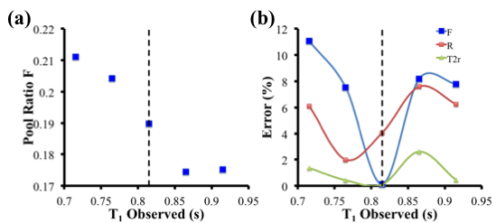

**Figure 4.** Effect on qMT fitted parameters as a result of measuring a T1 value different from the true tissue T1 value (dotted line). (a) Effect on the value of the pool ratio parameter F. (b) The error in fitted parameters for F, R and T2,r.

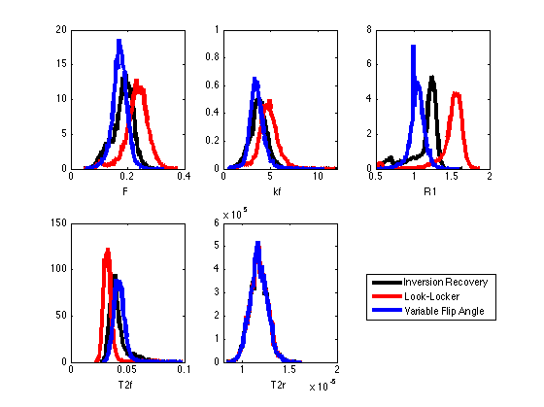

**Figure 5:** Normalized pooled histograms of single slice WM quantitative MT parameter values for 6 healthy subjects using double angle B1 maps and IR (black), LL (red), and VFA (blue) T1 maps.

**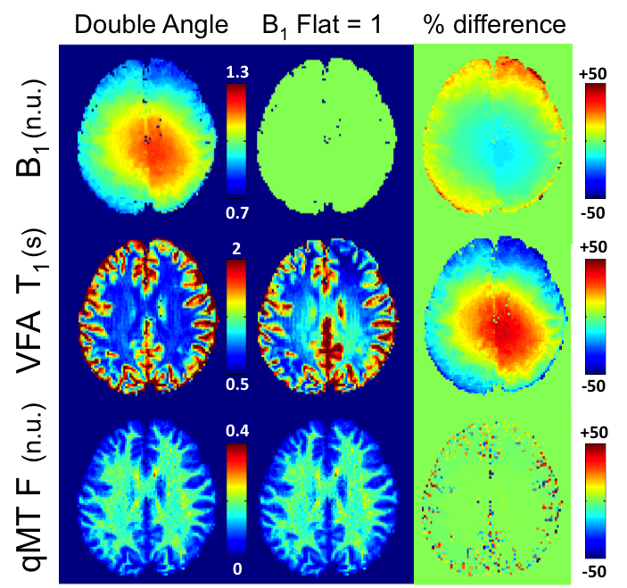**

**Figure 6:** A single subject comparison of qMT F maps fitted using DA and flat (B1 = 1) B1 maps and VFA T1 maps corrected using the corresponding B1 map.

**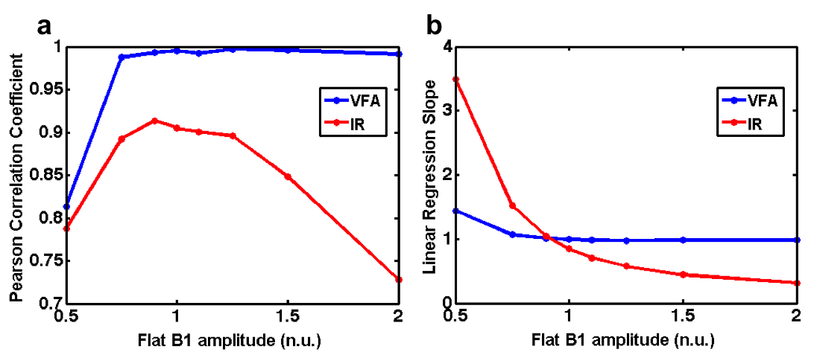**

**Figure 7:** Pooled (all subjects) whole brain Pearson correlation coefficients (a) and linear regression slopes (b) for qMT F values between the measured DA B1 maps and simulated flat B1 maps.

**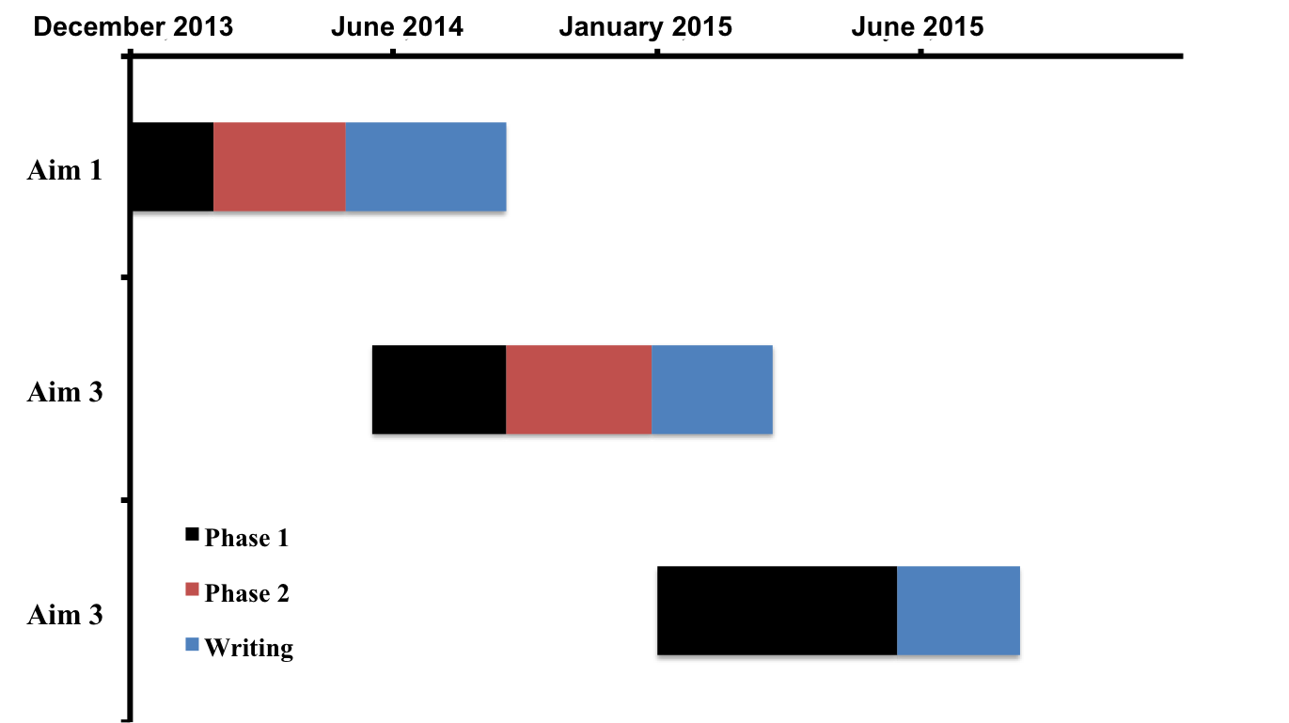**

**Figure 8.** Estimate timeline of the thesis project. Details for each aim are summarized in Section 6 of this document, and in Section 7 of the PhD Thesis Proposal submitted to the McGill Department of Biomedical Engineering in December 2012.

**APENDIX A**

**2014 ISMRM Conference Abstract – 1**

**(Submitted, 1st author)**

**Macintosh HD:Users:mathieuboudreau:Work:Documents:Abstracts:ISMRM2014:B1T1:Boudreau_Mathieu_ISMRM_2014_B1T1_Proof.pdf**

**APENDIX B**

**2013 endMS Conference Abstract**

**(Accepted, first author)**

**Title:** Effect of Different T1 Mapping Techniques on a Quantitative Magnetization Transfer MRI Biomarker for Myelin Density

**Name(s) of author(s):** Mathieu Boudreau, Nikola Stikov, G. Bruce Pike

**Name of the institution:** Montreal Neurological Institute

**Objective:** Quantitative MRI techniques, such as quantitative T1, T2, diffusion, and magnetization transfer (MT), have become the focus of research development for MS due to their promise of providing scanner and site independent MRI measures and better MS pathological specificity. Post-mortem studies in MS patient brains have shown stronger correlation between histological measures of myelin and the quantitative MT (qMT) parameter F (semi-solid to liquid pool magnetization ratio), relative to the MT ratio (MTR). An important requirement for qMT processing is an accurate T1 map. Recently, a comparison between three commonly used T1 techniques (inversion recovery - IR, Look-Locker - LL and variable flip angle - VFA) showed significant disagreement in values in white matter (WM). This study investigated the effects of different T1 techniques on the qMT parameter F, a biomarker for myelin density, in WM of healthy subjects.

**Methodology:** An in vivo MRI study comparing the effect of three T1 methods on qMT was performed on one healthy female (age 27). The protocol consisted of T1 maps acquired from IR, LL and VFA scans, a pulsed qMT acquisition protocol optimized for 3T, a structural MPRAGE, and additional scans required for qMT processing (B0, B1). Four periventricular ROIs were selected from a single slice above the ventricles, bilaterally in the frontal and occipital lobes.

**Results:** The mean qMT F value using IR T1 data was 0.14 ± 0.02 (unitless). Relative to IR, mean F values fitted with LL and VFA T1 maps were 16% higher and 12% lower respectively, and their standard deviations were 39% higher and 32% lower. F values for VFA were near the range expected from WM lesions. Lower variance in VFA F values suggests that fewer subjects may be required to achieve acceptable statistical power, but with the calibration of mean T1 values using an additional IR scan.

**APENDIX C**

**2014 ISMRM Conference Abstract – 2**

**(Submitted, 1st author)**

Macintosh HD:Users:mathieuboudreau:Work:Documents:Abstracts:ISMRM2014:qMT:Boudreau_Mathieu_ISMRM_2014_qMT_Proof.pdf

**APENDIX D**

**2014 ISMRM Conference Abstract – 3**

**(Submitted, 3rd author)**

Macintosh HD:Users:mathieuboudreau:Work:Documents:Abstracts:ISMRM2014:ISMRM_abstract_qMTLab.pdf

**APENDIX E**

**T1 mapping article - Magnetic Resonance in Medicine**

**(Submitted, 2nd author)**

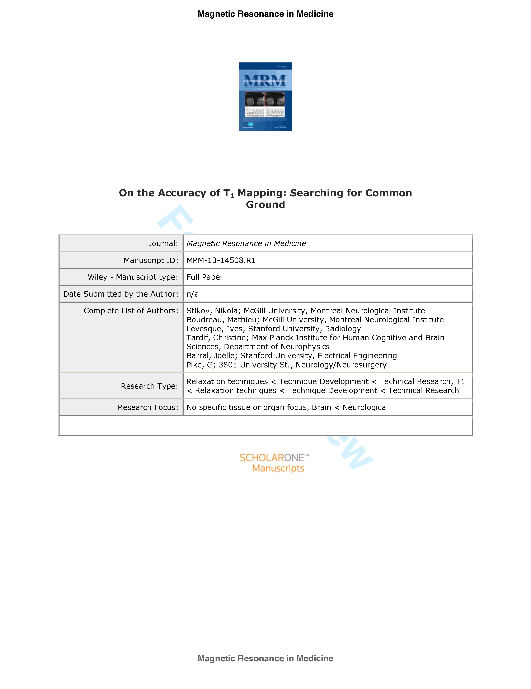

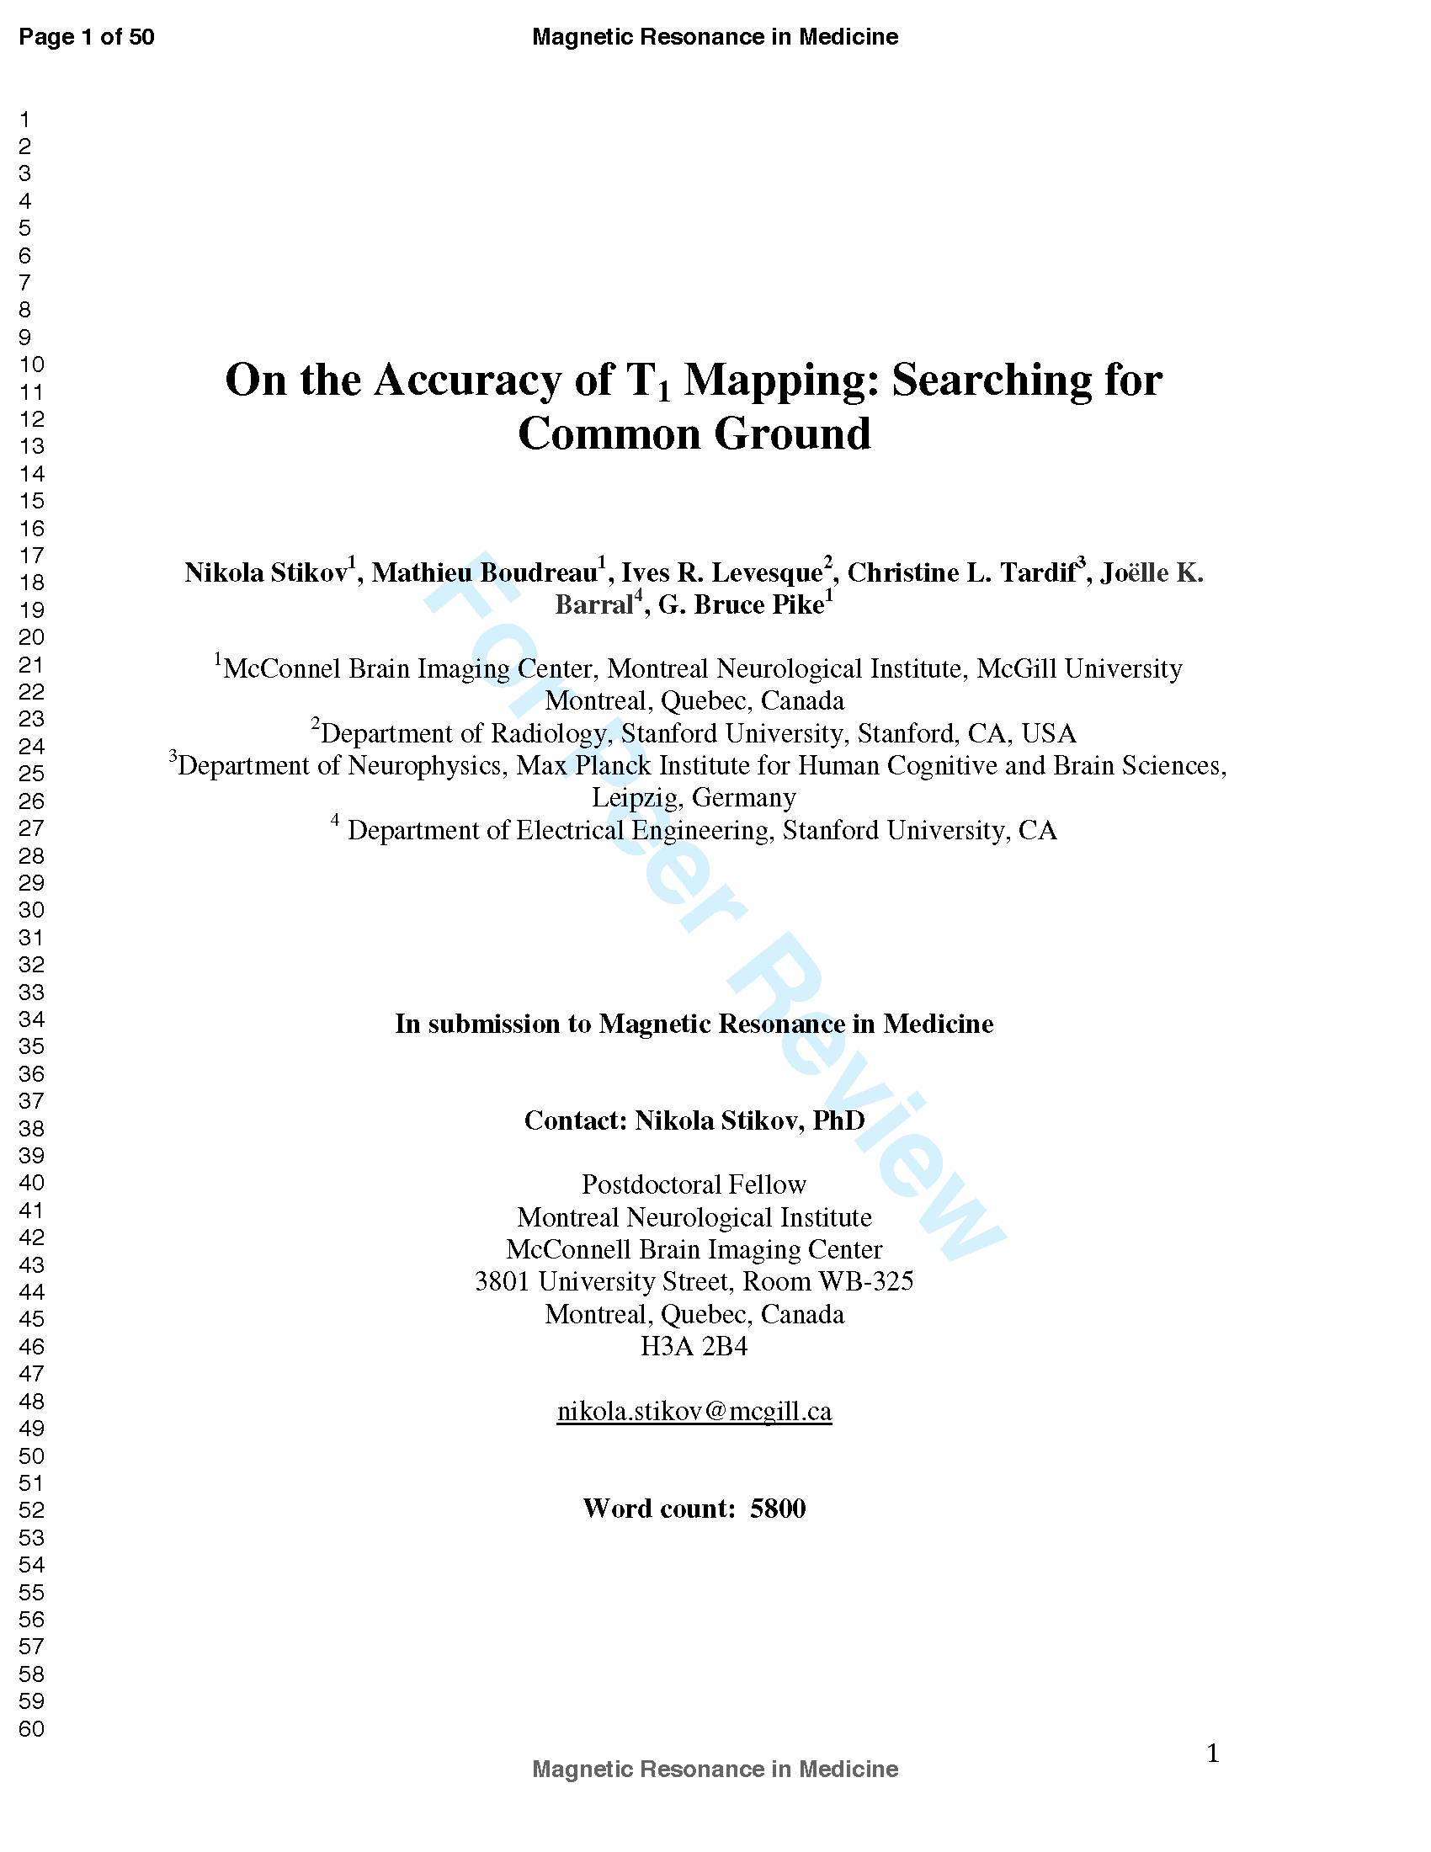

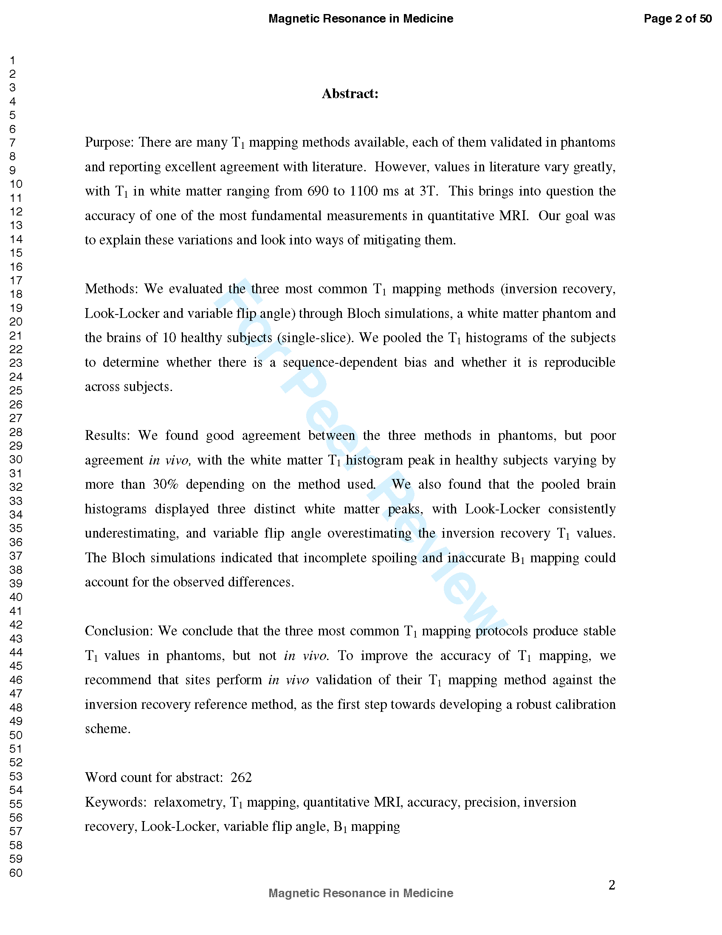

**References**

1. MSSC. <http://www.mssociety.ca/en/information>. MS Society of Canada 2012.

2. Polman CH, Reingold SC, Banwell B, Clanet M, Cohen JA, Filippi M, Fujihara K, Havrdova E, Hutchinson M, Kappos L, Lublin FD, Montalban X, O'Connor P, Sandberg-Wollheim M, Thompson AJ, Waubant E, Weinshenker B, Wolinsky JS. Diagnostic criteria for multiple sclerosis: 2010 revisions to the McDonald criteria. Ann Neurol 2011;69(2):292-302.

3. Frohman EM, Racke MK, Raine CS. Multiple sclerosis--the plaque and its pathogenesis. The New England journal of medicine 2006;354(9):942-955.

4. McFarland HF, Martin R. Multiple sclerosis: a complicated picture of autoimmunity. Nature immunology 2007;8(9):913-919.

5. Noseworthy JH, Lucchinetti C, Rodriguez M, Weinshenker BG. Multiple sclerosis. The New England journal of medicine 2000;343(13):938-952.

6. Peterson JW, Bo L, Mork S, Chang A, Trapp BD. Transected neurites, apoptotic neurons, and reduced inflammation in cortical multiple sclerosis lesions. Ann Neurol 2001;50(3):389-400.

7. Schmierer K, Thavarajah JR, An SF, Brandner S, Miller DH, Tozer DJ. Effects of formalin fixation on magnetic resonance indices in multiple sclerosis cortical gray matter. Journal of magnetic resonance imaging : JMRI 2010;32(5):1054-1060.

8. Stadelmann C, Albert M, Wegner C, Bruck W. Cortical pathology in multiple sclerosis. Current opinion in neurology 2008;21(3):229-234.

9. Perry VH, Anthony DC. Axon damage and repair in multiple sclerosis. Philosophical transactions of the Royal Society of London Series B, Biological sciences 1999;354(1390):1641-1647.

10. Lassmann H. Axonal and neuronal pathology in multiple sclerosis: What have we learnt from animal models. Experimental neurology 2010;225(1):2-8.

11. Staugaitis SM, Chang A, Trapp BD. Cortical pathology in multiple sclerosis: experimental approaches to studies on the mechanisms of demyelination and remyelination. Acta Neurologica Scandinavica 2012;126:97-102.

12. Klaver R, De Vries HE, Schenk GJ, Geurts JJ. Grey matter damage in multiple sclerosis: A pathology perspective. Prion 2013;7(1).

13. Brownell B, Hughes JT. The distribution of plaques in the cerebrum in multiple sclerosis. Journal of neurology, neurosurgery, and psychiatry 1962;25:315-320.

14. Calabrese M, Agosta F, Rinaldi F, Mattisi I, Grossi P, Favaretto A, Atzori M, Bernardi V, Barachino L, Rinaldi L, Perini P, Gallo P, Filippi M. Cortical Lesions and Atrophy Associated With Cognitive Impairment in Relapsing-Remitting Multiple Sclerosis. Archives of neurology 2009;66(9):1144-1150.

15. Simon JH, Li D, Traboulsee A, Coyle PK, Arnold DL, Barkhof F, Frank JA, Grossman R, Paty DW, Radue EW, Wolinsky JS. Standardized MR imaging protocol for multiple sclerosis: Consortium of MS Centers consensus guidelines. AJNR American journal of neuroradiology 2006;27(2):455-461.

16. Schmierer K, Scaravilli F, Altmann DR, Barker GJ, Miller DH. Magnetization transfer ratio and myelin in postmortem multiple sclerosis brain. Ann Neurol 2004;56(3):407-415.

17. Schmierer K, Tozer DJ, Scaravilli F, Altmann DR, Barker GJ, Tofts PS, Miller DH. Quantitative magnetization transfer imaging in postmortem multiple sclerosis brain. Journal of magnetic resonance imaging : JMRI 2007;26(1):41-51.

18. Levesque I, Sled JG, Narayanan S, Santos AC, Brass SD, Francis SJ, Arnold DL, Pike GB. The role of edema and demyelination in chronic T-1 black holes: A quantitative magnetization transfer study. Journal of Magnetic Resonance Imaging 2005;21(2):103-110.

19. Levesque IR, Giacomini PS, Narayanan S, Ribeiro LT, Sled JG, Arnold DL, Pike GB. Quantitative magnetization transfer and myelin water imaging of the evolution of acute multiple sclerosis lesions. Magnetic resonance in medicine : official journal of the Society of Magnetic Resonance in Medicine / Society of Magnetic Resonance in Medicine 2010;63(3):633-640.

20. Tardif CL, Bedell BJ, Eskildsen SF, Collins DL, Pike GB. Quantitative Magnetic Resonance Imaging of Cortical Multiple Sclerosis Pathology. Multiple Sclerosis International 2012;2012:13.

21. Arnold DL, Matthews PM. MRI in the diagnosis and management of multiple sclerosis. Neurology 2002;58(8 suppl 4):S23-S31.

22. Anderson VM, Fox NC, Miller DH. Magnetic resonance imaging measures of brain atrophy in multiple sclerosis. Journal of Magnetic Resonance Imaging 2006;23(5):605-618.

23. De Stefano N, Battaglini M, Smith SM. Measuring Brain Atrophy in Multiple Sclerosis. Journal of Neuroimaging 2007;17:10S-15S.

24. Sepulcre J, Goni J, Masdeu JC, Bejarano B, de Mendizabal NV, Toledo JB, Villoslada P. Contribution of White Matter Lesions to Gray Matter Atrophy in Multiple Sclerosis. Archives of neurology 2009;66(2):173-179.

25. Derakhshan M, Caramanos Z, Giacomini PS, Narayanan S, Maranzano J, Francis SJ, Arnold DL, Collins DL. Evaluation of automated techniques for the quantification of grey matter atrophy in patients with multiple sclerosis. NeuroImage 2010;52(4):1261-1267.

26. Filippi M, Agosta F. Magnetic resonance techniques to quantify tissue damage, tissue repair, and functional cortical reorganization in multiple sclerosis. Progress in brain research 2009;175:465-482.

27. Kidd D, Barkhof F, McConnell R, Algra PR, Allen IV, Revesz T. Cortical lesions in multiple sclerosis. Brain : a journal of neurology 1999;122 ( Pt 1):17-26.

28. Bedell BJ, Narayana PA. Implementation and evaluation of a new pulse sequence for rapid acquisition of double inversion recovery images for simultaneous suppression of white matter and CSF. Journal of magnetic resonance imaging : JMRI 1998;8(3):544-547.

29. Filippi M, Rocca MA. Multiple sclerosis and allied white matter diseases. Neurological sciences : official journal of the Italian Neurological Society and of the Italian Society of Clinical Neurophysiology 2008;29 Suppl 3:319-322.

30. Savadjiev P, Campbell JS, Pike GB, Siddiqi K. 3D curve inference for diffusion MRI regularization and fibre tractography. Medical image analysis 2006;10(5):799-813.

31. MamayyezSiahka P, Campbell JSW, Savadjiev P, Pike GB, Siddiqi K. Beyond crossing fibres: Probabilistic tractography of complex subvoxel fibre geometries. MICCAI Workshop on Diffusion Modelling 2009.

32. Wedeen VJ, Hagmann P, Tseng WY, Reese TG, Weisskoff RM. Mapping complex tissue architecture with diffusion spectrum magnetic resonance imaging. Magnetic resonance in medicine : official journal of the Society of Magnetic Resonance in Medicine / Society of Magnetic Resonance in Medicine 2005;54(6):1377-1386.

33. Wedeen VJ, Wang RP, Schmahmann JD, Benner T, Tseng WYI, Dai G, Pandya DN, Hagmann P, D'Arceuil H, de Crespignya AJ. Diffusion spectrum magnetic resonance imaging (DSI) tractography of crossing fibers. NeuroImage 2008;41(4):1267-1277.

34. Pagani E, Bammer R, Horsfield MA, Rovaris M, Gass A, Ciccarelli O, Filippi M. Diffusion MR imaging in multiple sclerosis: technical aspects and challenges. AJNR American journal of neuroradiology 2007;28(3):411-420.

35. Schmierer K, Wheeler-Kingshott CA, Boulby PA, Scaravilli F, Altmann DR, Barker GJ, Tofts PS, Miller DH. Diffusion tensor imaging of post mortem multiple sclerosis brain. NeuroImage 2007;35(2):467-477.

36. Calabrese M, Rinaldi F, Seppi D, Favaretto A, Squarcina L, Mattisi I, Perini P, Bertoldo A, Gallo P. Cortical diffusion-tensor imaging abnormalities in multiple sclerosis: a 3-year longitudinal study. Radiology 2011;261(3):891-898.

37. Wolff SD, Balaban RS. Magnetization transfer contrast (MTC) and tissue water proton relaxation in vivo. Magnetic resonance in medicine : official journal of the Society of Magnetic Resonance in Medicine / Society of Magnetic Resonance in Medicine 1989;10(1):135-144.

38. Henkelman RM, Huang X, Xiang QS, Stanisz GJ, Swanson SD, Bronskill MJ. Quantitative interpretation of magnetization transfer. Magnetic resonance in medicine : official journal of the Society of Magnetic Resonance in Medicine / Society of Magnetic Resonance in Medicine 1993;29(6):759-766.

39. Graham SJ, Henkelman RM. Understanding pulsed magnetization transfer. Journal of magnetic resonance imaging : JMRI 1997;7(5):903-912.

40. Henkelman RM, Stanisz GJ, Graham SJ. Magnetization transfer in MRI: a review. NMR in biomedicine 2001;14(2):57-64.

41. Ge Y, Kolson DL, Babb JS, Mannon LJ, Grossman RI. Whole brain imaging of HIV-infected patients: quantitative analysis of magnetization transfer ratio histogram and fractional brain volume. AJNR American journal of neuroradiology 2003;24(1):82-87.

42. Dousset V, Armand JP, Huot P, Viaud B, Caille JM. Magnetization transfer imaging in AIDS-related brain diseases. Neuroimaging clinics of North America 1997;7(3):447-460.

43. Wu Y, Storey P, Carrillo A, Saglamer C, Cohen BA, Epstein LG, Edelman RR, Ragin AB. Whole brain and localized magnetization transfer measurements are associated with cognitive impairment in patients infected with human immunodeficiency virus. AJNR American journal of neuroradiology 2008;29(1):140-145.

44. Fornari E, Maeder P, Meuli R, Ghika J, Knyazeva MG. Demyelination of superficial white matter in early Alzheimer's disease: a magnetization transfer imaging study. Neurobiology of aging 2012;33(2):428 e427-419.

45. Giulietti G, Bozzali M, Figura V, Spano B, Perri R, Marra C, Lacidogna G, Giubilei F, Caltagirone C, Cercignani M. Quantitative magnetization transfer provides information complementary to grey matter atrophy in Alzheimer's disease brains. Neuroimage 2012;59(2):1114-1122.

46. Ridha BH, Tozer DJ, Symms MR, Stockton KC, Lewis EB, Siddique MM, MacManus DG, Rossor MN, Fox NC, Tofts PS. Quantitative magnetization transfer imaging in Alzheimer disease. Radiology 2007;244(3):832-837.

47. Wiest R, Burren Y, Hauf M, Schroth G, Pruessner J, Zbinden M, Cattapan-Ludewig K, Kiefer C. Classification of mild cognitive impairment and Alzheimer disease using model-based MR and magnetization transfer imaging. AJNR American journal of neuroradiology 2013;34(4):740-746.

48. Li X, Majumdar S. Quantitative MRI of articular cartilage and its clinical applications. Journal of magnetic resonance imaging : JMRI 2013;38(5):991-1008.

49. Stikov N, Keenan KE, Pauly JM, Smith RL, Dougherty RF, Gold GE. Cross-relaxation imaging of human articular cartilage. Magnetic resonance in medicine : official journal of the Society of Magnetic Resonance in Medicine / Society of Magnetic Resonance in Medicine 2011;66(3):725-734.

50. Sled JG, Pike GB. Quantitative imaging of magnetization transfer exchange and relaxation properties in vivo using MRI. Magnetic resonance in medicine : official journal of the Society of Magnetic Resonance in Medicine / Society of Magnetic Resonance in Medicine 2001;46(5):923-931.

51. Yarnykh VL. Pulsed Z-spectroscopic imaging of cross-relaxation parameters in tissues for human MRI: theory and clinical applications. Magnetic resonance in medicine : official journal of the Society of Magnetic Resonance in Medicine / Society of Magnetic Resonance in Medicine 2002;47(5):929-939.

52. Cercignani M, Alexander DC. Optimal acquisition schemes for in vivo quantitative magnetization transfer MRI. Magnetic resonance in medicine : official journal of the Society of Magnetic Resonance in Medicine / Society of Magnetic Resonance in Medicine 2006;56(4):803-810.

53. Portnoy S, Stanisz GJ. Modeling pulsed magnetization transfer. Magnetic resonance in medicine : official journal of the Society of Magnetic Resonance in Medicine / Society of Magnetic Resonance in Medicine 2007;58(1):144-155.

54. Ramani A, Dalton C, Miller DH, Tofts PS, Barker GJ. Precise estimate of fundamental in-vivo MT parameters in human brain in clinically feasible times. Magnetic resonance imaging 2002;20(10):721-731.

55. Levesque IR, Sled JG, Narayanan S, Giacomini PS, Ribeiro LT, Arnold DL, Pike GB. Reproducibility of quantitative magnetization-transfer imaging parameters from repeated measurements. Magnetic resonance in medicine : official journal of the Society of Magnetic Resonance in Medicine / Society of Magnetic Resonance in Medicine 2010;64(2):391-400.

56. Levesque IR, Sled JG, Pike GB. Iterative optimization method for design of quantitative magnetization transfer imaging experiments. Magnetic resonance in medicine : official journal of the Society of Magnetic Resonance in Medicine / Society of Magnetic Resonance in Medicine 2011;66(3):635-643.

57. Yarnykh VL. Fast macromolecular proton fraction mapping from a single off-resonance magnetization transfer measurement. Magnetic resonance in medicine : official journal of the Society of Magnetic Resonance in Medicine / Society of Magnetic Resonance in Medicine 2012;68(1):166-178.

58. Underhill HR, Rostomily RC, Mikheev AM, Yuan C, Yarnykh VL. Fast bound pool fraction imaging of the in vivo rat brain: association with myelin content and validation in the C6 glioma model. NeuroImage 2011;54(3):2052-2065.

59. Gloor M, Scheffler K, Bieri O. Quantitative magnetization transfer imaging using balanced SSFP. Magnetic resonance in medicine : official journal of the Society of Magnetic Resonance in Medicine / Society of Magnetic Resonance in Medicine 2008;60(3):691-700.

60. Lustig M, Donoho D, Pauly JM. Sparse MRI: The application of compressed sensing for rapid MR imaging. Magnetic resonance in medicine : official journal of the Society of Magnetic Resonance in Medicine / Society of Magnetic Resonance in Medicine 2007;58(6):1182-1195.

61. Gamper U, Boesiger P, Kozerke S. Compressed sensing in dynamic MRI. Magnetic resonance in medicine : official journal of the Society of Magnetic Resonance in Medicine / Society of Magnetic Resonance in Medicine 2008;59(2):365-373.

62. Menzel MI, Tan ET, Khare K, Sperl JI, King KF, Tao XD, Hardy CJ, Marinelli L. Accelerated Diffusion Spectrum Imaging in the Human Brain Using Compressed Sensing. Magnetic Resonance in Medicine 2011;66(5):1226-1233.

63. Doneva M, Bornert P, Eggers H, Stehning C, Senegas J, Mertins A. Compressed sensing reconstruction for magnetic resonance parameter mapping. Magnetic resonance in medicine : official journal of the Society of Magnetic Resonance in Medicine / Society of Magnetic Resonance in Medicine 2010;64(4):1114-1120.

64. Li W, Griswold M, Yu X. Fast cardiac T(1) mapping in mice using a model-based compressed sensing method. Magnetic resonance in medicine : official journal of the Society of Magnetic Resonance in Medicine / Society of Magnetic Resonance in Medicine 2011.

65. Sumpf TJ, Uecker M, Boretius S, Frahm J. Model-Based Nonlinear Inverse Reconstruction for T2 Mapping Using Highly Undersampled Spin-Echo MRI. Journal of Magnetic Resonance Imaging 2011;34(2):420-428.

66. Ji SH, Xue Y, Carin L. Bayesian compressive sensing. Ieee T Signal Proces 2008;56(6):2346-2356.

67. Bilgic B, Goyal VK, Adalsteinsson E. Multi-contrast reconstruction with Bayesian compressed sensing. Magnetic resonance in medicine : official journal of the Society of Magnetic Resonance in Medicine / Society of Magnetic Resonance in Medicine 2011;66(6):1601-1615.

68. Lustig M, Pauly JM. SPIRiT: Iterative self-consistent parallel imaging reconstruction from arbitrary k-space. Magnetic resonance in medicine : official journal of the Society of Magnetic Resonance in Medicine / Society of Magnetic Resonance in Medicine 2010;64(2):457-471.

69. Uecker M, Lai P, Murphy MJ, Virtue P, Elad M, Pauly JM, Vasanawala SS, Lustig M. ESPIRiT—an eigenvalue approach to autocalibrating parallel MRI: Where SENSE meets GRAPPA. Magnetic Resonance in Medicine 2013:n/a-n/a.

70. Weller DS, Polimeni JR, Grady L, Wald LL, Adalsteinsson E, Goyal VK. Combined Compressed Sensing and Parallel Mri Compared for Uniform and Random Cartesian Undersampling of K-Space. 2011 Ieee International Conference on Acoustics, Speech, and Signal Processing 2011:553-556.

71. She H, Chen R-R, Liang D, DiBella EVR, Ying L. Sparse BLIP: BLind Iterative Parallel imaging reconstruction using compressed sensing. Magnetic Resonance in Medicine 2013:n/a-n/a.

72. Wu B, Millane RP, Watts R, Bones PJ. Prior estimate-based compressed sensing in parallel MRI. Magnetic resonance in medicine : official journal of the Society of Magnetic Resonance in Medicine / Society of Magnetic Resonance in Medicine 2011;65(1):83-95.

73. Chang CH, Ji J. Compressed Sensing MRI with Multichannel Data Using Multicore Processors. Magnetic Resonance in Medicine 2010;64(4):1135-1139.

74. Liang D, Liu B, Wang JJ, Ying L. Accelerating SENSE Using Compressed Sensing. Magnetic Resonance in Medicine 2009;62(6):1574-1584.

75. Liu B, Zou YM, Ying L. SparseSENSE: Application of compressed sensing in parallel MRI. 2008 International Special Topic Conference on Information Technology and Applications in Biomedicine, Vols 1 and 2 2008:261-264.

76. Ji JX, Zhao C, Lang T. Compressed Sensing Parallel Magnetic Resonance Imaging. 2008 30th Annual International Conference of the IEEE Engineering in Medicine and Biology Society, Vols 1-8 2008:1671-1674.

77. Yarnykh VL. Optimal radiofrequency and gradient spoiling for improved accuracy of T1 and B1 measurements using fast steady-state techniques. Magnetic resonance in medicine : official journal of the Society of Magnetic Resonance in Medicine / Society of Magnetic Resonance in Medicine 2010;63(6):1610-1626.

78. Yarnykh VL. Actual flip-angle imaging in the pulsed steady state: a method for rapid three-dimensional mapping of the transmitted radiofrequency field. Magnetic resonance in medicine : official journal of the Society of Magnetic Resonance in Medicine / Society of Magnetic Resonance in Medicine 2007;57(1):192-200.

79. Sacolick LI, Wiesinger F, Hancu I, Vogel MW. B1 mapping by Bloch-Siegert shift. Magnetic resonance in medicine : official journal of the Society of Magnetic Resonance in Medicine / Society of Magnetic Resonance in Medicine 2010;63(5):1315-1322.

80. Tardif CLS, N.; Levesque, I.R.; Pike, G.B. Impact of Three B1 Mapping Techniques on Variable Flip Angle T1 Measurements. Proc Intl Soc Mag Reson Med 2011;19.

81. Zhang T, Pauly J, Levesque I. Accelerating Parameter Mapping with a Locally Low Rank Constraint. In Proceedings of the 21st Annual Meeting of ISMRM 2013:p.2458.